**PLACEMENT EMPOWERMENT PROGRAM**

**CLOUD COMPUTING AND DEVOPS CENTRE**

Set Up a Load Balancer in the Cloud Configure a load balancer to distribute traffic across multiple VMs hosting your web application.

Name: SHARUKA S Department: ADS

**Steps**

**Step**1:

Launch 2 instances:: name the first instance "WebServer1," select Amazon Linux as the OS, and choose the t2.micro instance type. For the Key Pair, either select an existing one or create a new key pair to use for SSH access. Under Network Settings, click "Edit" and ensure "Allow HTTP traffic from the internet" is checked to enable web traffic. Keep the storage size at the default 8 GB, Repeat the same steps for the second instance, name it "WebServer2."

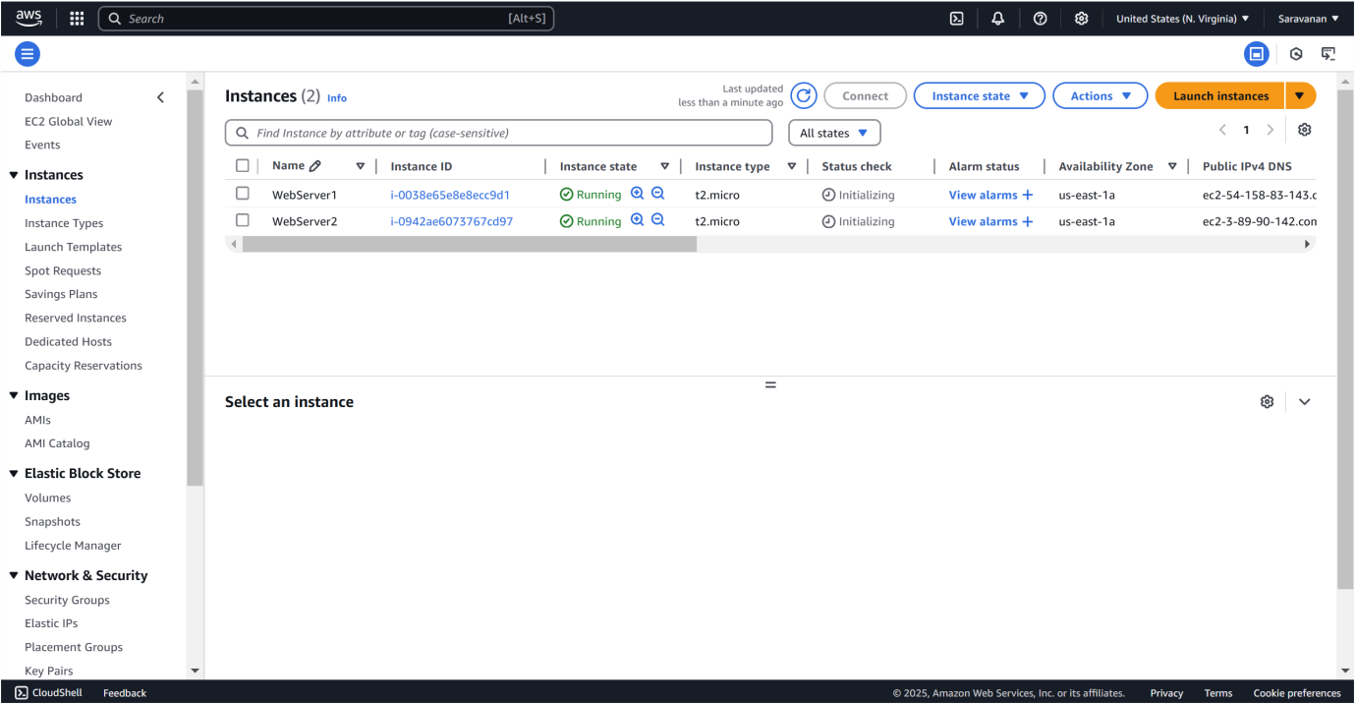

Step 2:

Click on WebServer1, then click Connect.

Copy the example in SSH client

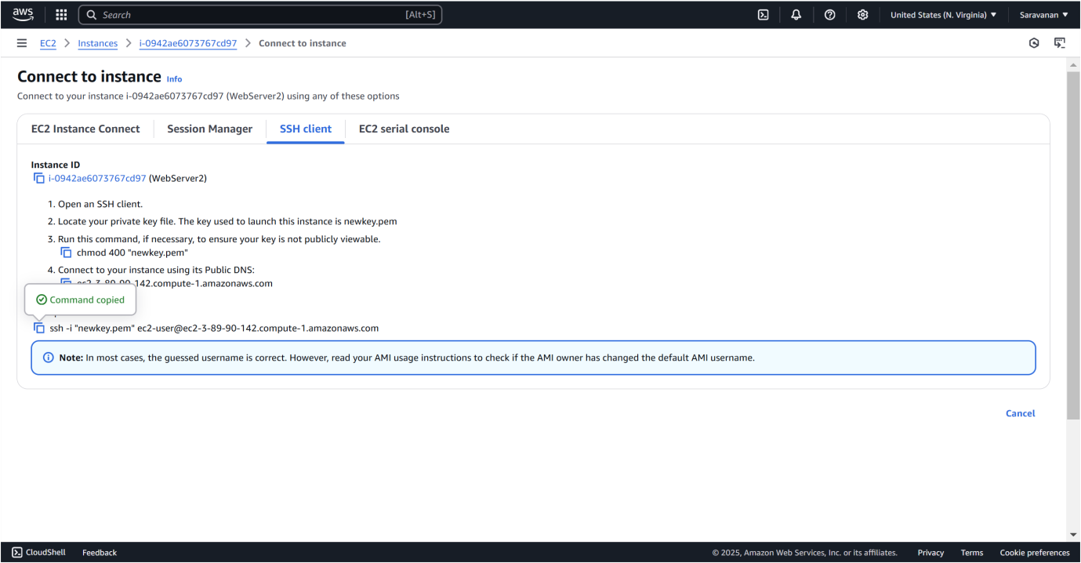

Step 3:

Run the following commands to install and start a web server



 







Step 3:

Repeat these steps for WebServer2 but change the message in the last command to:





Step 4:

1. Go to the EC2 Dashboard.

1. Scroll down and click on Target Groups under "Load Balancing."
2. Click Create Target Group.

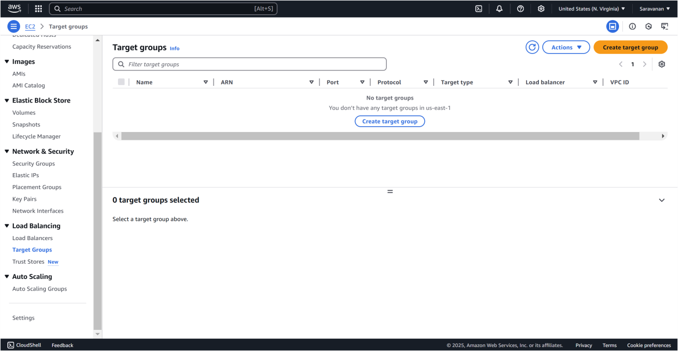

Step 5:

Select Instances as the target type, name it, set the Protocol to HTTP and Port to 80, and choose the same VPC as your EC2 instances (usually the default VPC). Keep the Health Check Path as / to verify the web server's status. Click Next, select both WebServer1 and WebServer2 under "Register Targets," click Include as pending below, and then create the target group.

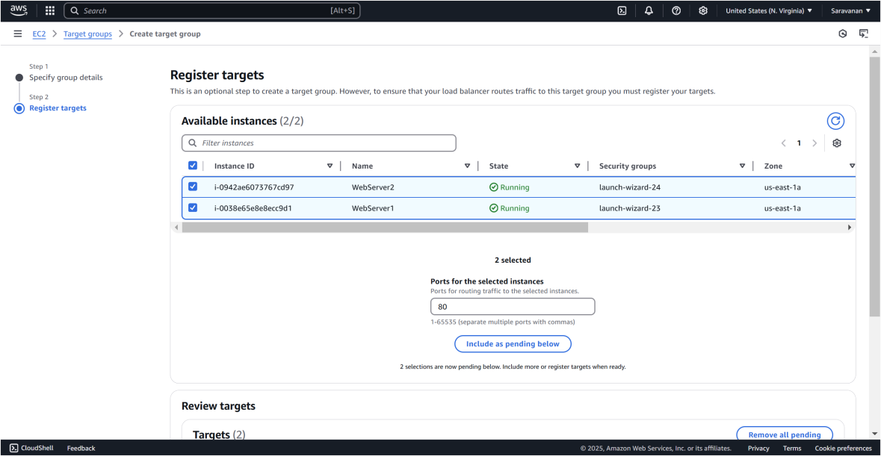

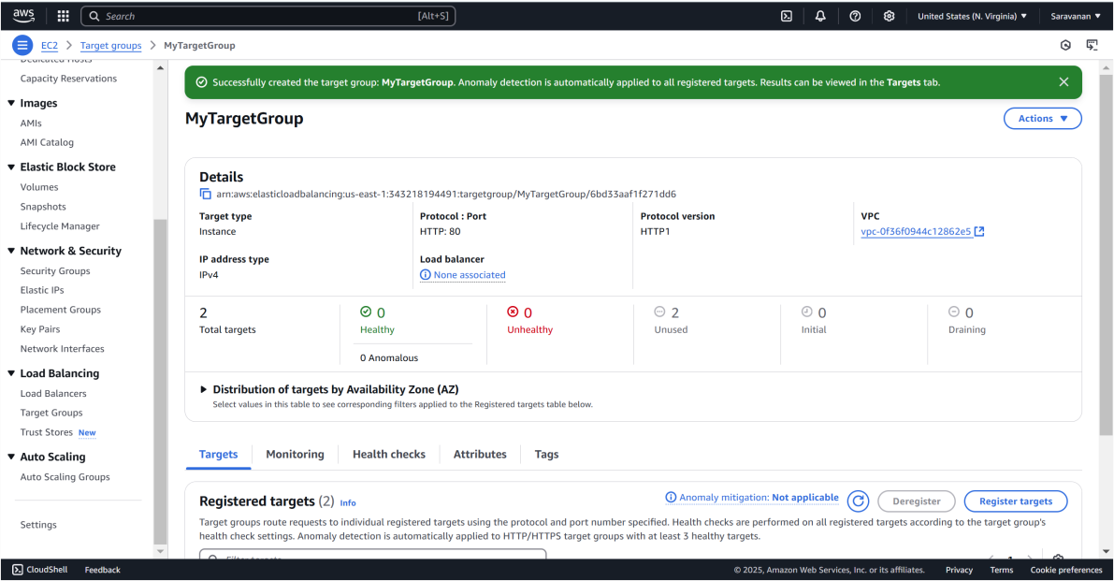

Step 6:

In the EC2 Dashboard, go to Load Balancers under "Load Balancing" and click Create Load Balancer. Select Application Load Balancer and configure it: name it, set the Scheme to Internet-facing, IP Address Type to IPv4, and ensure the listener is HTTP on port 80. Select the VPC and at least two subnets for high availability. Skip the security settings since this is HTTP. On the Security Groups page, choose or create a security group that allows HTTP traffic. On the Routing page, select the previously created target group (e.g., "MyTargetGroup") and click Create Load Balancer.

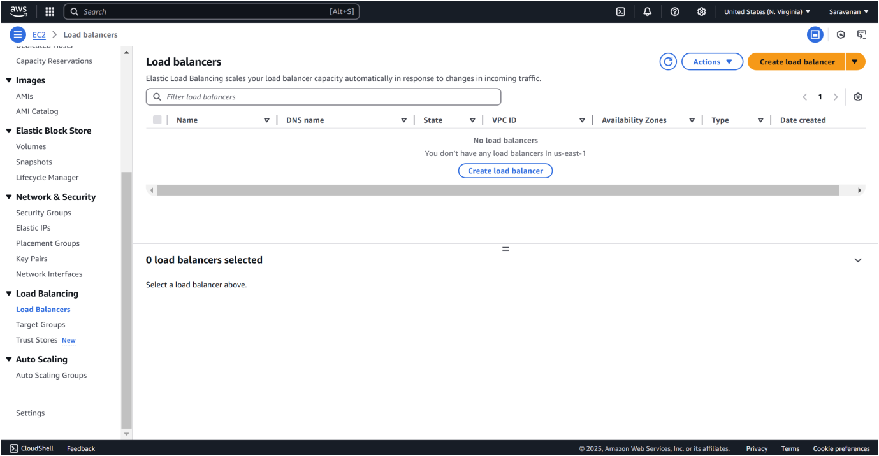

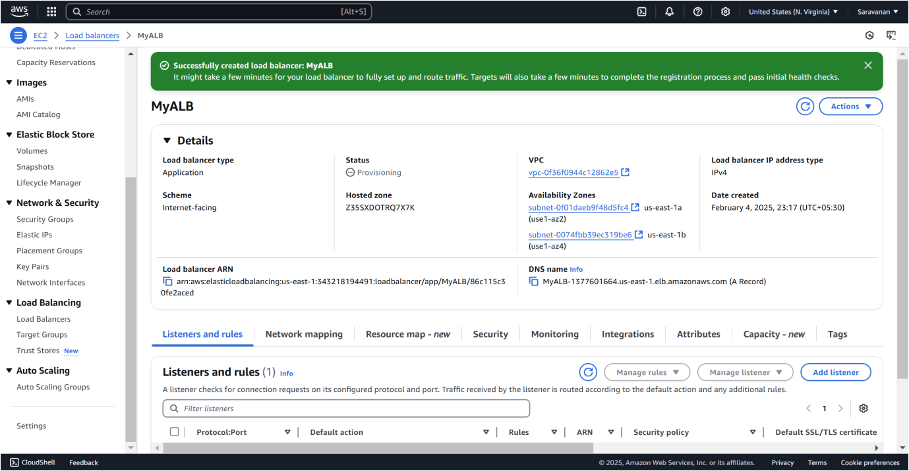

Step 7:

To verify the functionality of your Load Balancer:

1. Go to the Load Balancers section in the AWS Management Console.
2. Select your Load Balancer and find its DNS name under the Description tab.
3. Copy the DNS name and open it in your browser.
4. Refresh the page to confirm that traffic is being alternated between the two EC2 instances. You should see the messages **"Hello from WebServer1!"** and **"Hello from WebServer2!"** displayed alternately.